Specifications = 86002171

Uses LoRaWAN 1.0.2

Input = 3.3 - 5VDC

Temp = -40 to 85F

Humidity = 20 - 90 % noncondensing

926MHz UHF

Higher Spreading Factor means lower data rate, higher sensitivity and longer range.

Gain is simply stealing radiated energy from some directions to intensify others. This is true for both light or RF signals. Gain comes with directivity, and we don’t always want it. More gain is not automatically better, it depends on the application. If you don’t intend to point your antenna in a particular direction, then you don’t want gain.

Dev guide = s000612

PG 11 = getting started

Default = AT commands using serial I/O

Battery = PG 24

Pin info = 26

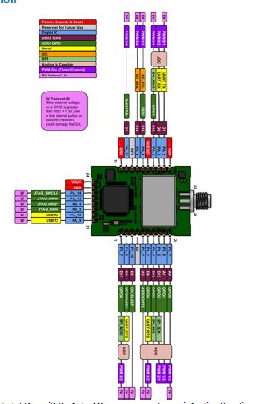

Pin config:

1 = input (3.3-5V)

2 = UART_TX

3 = UART_RX

5 = reset (has built in pull up, pull low to reset)

10 = GND

25 = GND

** from page 30

Serial Pinout Notes  
Out of the box, these pins are available for serial applications. Refer to the mechanical drawing for your model for  
pin locations.  
2 Dout/TX  
3 Din/RX  
9 DTR  
12 CTS  
13 On/Sleep  
16 RTS

PCB Layout guidelines = PG 70

At Command book:

To test, send “AT”.

Should get “OK”.

AT&F Reset to Factory Defaults

Changes the current settings to the factory defaults, but does not store them. To store the default settings, use

with AT&W. Otherwise, resetting or power cycling the device restores the previous settings.

AT&W Save Configuration

Writes all configuration settings displayed in AT&V to flash memory.

AT+IPR Serial Speed

Sets serial baud rate for interface on header pins 2 and 3. Changes to this setting take effect after a save and

reboot of the Dot.115200 = Default

AT+FSB Frequency Sub-Band (915MHz models only)

Configures the frequency sub-band for 915MHz models. This enables hybrid mode for private network channel

Management. May be concern??

AT+JOIN Join Network

Join network. For US915 and EU868 models +NI, +NK must match gateway settings in order to join. US915 must

also match +FSB setting.

AT+NJM Network Join Mode

Controls how the end device establishes communications with the gateway.

When AT+NJM=2 (AUTO_OTA) and AT+PS is set to 1 the session is not be defaulted on reset or power.

When AT+NJM=1 (OTA) AT+PS will not be applied and session stays in flash in either case.

Set to 3 for peer to peer

AT+NA Network Address

Sets network address in MANUAL join mode, the server will assign an address in OTA modes.

**EXAMPLES  
Network Configuration and Joining

Configure Network ID and Network Key with either a hexadecimal value or name/passphrase.

To configure with a hexadecimal value, provide a first argument of 0:

AT+NI=0,0011223344556677

OK

AT+NK=0,00112233445566770011223344556677

OK

To configure with a name/passphrase value provide a first argument of 1:

AT+NI=1,MTS-LORA-1

OK

AT+NK=1,MTS-LORA-PASSPHRASE

OK

Peer to Peer

mDots using 1.0.8 AT Firmware or Library can be configured for Peer to Peer communication. To allow

communication between mDots, configure two or more mDots with the same network settings. Enabling ACKs

guarantees packet delivery; however, this may disrupt higher level protocols such as zmodem or ymodem file

transfers. Communication between mDots is half-duplex, so both ends should not transmit at the same time or

communication will be disrupted.

The frequency can be set for US 915 models. We advise using 915.5-919.7 to avoid interference with LoRa

Networks.

For Europe 868 models, use a fixed frequency, 869.85, with 7 dBm power setting to allow 100% duty-cycle usage.

Script for peer to peer:

AT+NJM=3

AT+NA=00112233

AT+NSK=00112233001122330011223300112233

AT+DSK=33221100332211003322110033221100

AT+TXDR=DR8 (US:DR8-DR13,EU:DR0-DR6)

AT+TXF=915500000 (US-ONLY:915.5-919.7)

AT&W

ATZ

AT+SD

** Can adjust many more parameters! Read up!

Like:

AT+TXP Transmit Power

AT+ANT Antenna Gain

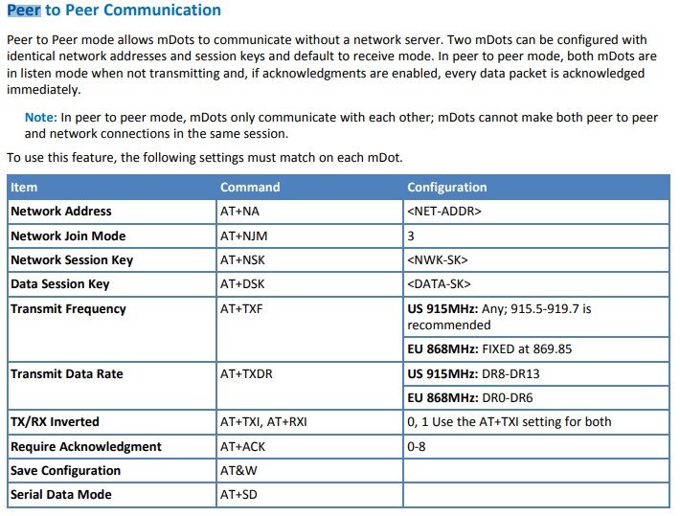

Antennas:

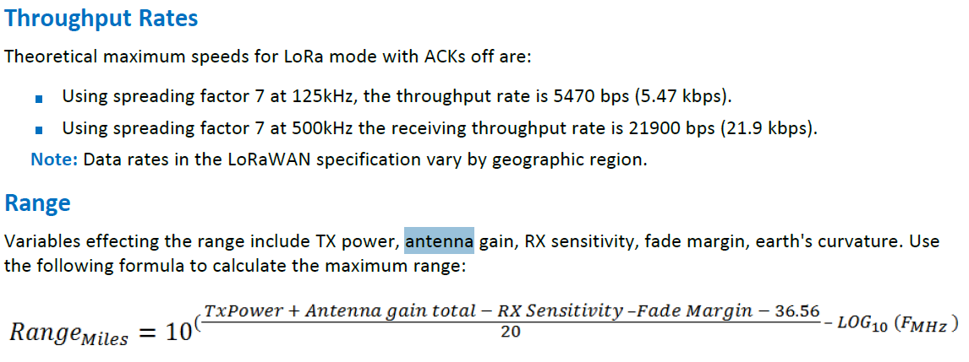

Ideas:

<https://www.arrow.com/en/products/2702273/phoenix-contact>

<https://www.arrow.com/en/products/x000016/arduino-corporation>

<https://www.arrow.com/en/products/w1063m/pulse-electronics-corporation>

<https://www.arrow.com/en/products/w1063/pulse-electronics-corporation>

<https://www.arrow.com/en/products/2019320001/molex>